Известия Гомельского государственного университета
имени Ф. Скорины, №6(39), 1, 2006

УДК 535.16:534.341

Investigation of thermophysical and dissipative properties of magnetoactive media using method of resonant photoacoustic spectroscopy

G. S. Mityurich¹, A. N. Emelyanovich², R. M. Burbelo³

Introduction

Investigation of physical and thermophysical properties of condensed media is one of important objectives both fundamental and applied character. There is a range of methods that gives possibility to measure thermophysical parameters of condensed media. One of these is method of photoacoustic spectroscopy, based on thermooptical generation of acoustic waves in media, absorbing modulated laser radiation [1-3]. Photoacoustic signal parameters can depend on characteristics absorbed radiation and on optical, thermophysical, acoustical, non-linear, dissipative, dichroic properties of absorbing media [3]. Lately is being developed method of resonance photoacoustic spectroscopy [4-9].Usage in this method as exciting bessel light beams (BLB) radiation is determined by presence of some specific properties, for example, non-diffraction spreading in space, presence in energy flow TH-mode apart axled radial constituent and so on. BLB have big perspective of usage in thermophycics, biophysics, medicine, nanotechnologies, integral and digital optics [10-12].
This work is devoted to investigation of thermophysical properties of inner stressed absorbing magnetoactive samples using Photoacoustic method at generation thermoelastic waves by different BLB modes.
Theory

The properties of magnetoactive sample can be described with the help of material equations
$\begin{matrix}E=\left(ε^{−1}+{iG}^{x}\right)D, \\ B=μH, μ=1,\end{matrix}$ (1)
where $G^{x}$ is antisimmetrical complex tensor of 2nd rank, dual to vector of magnetic gyration $G$, with the real part $\text{Re}G^{x}=G^{'}$ defining the specific rotation of polarization , while imaginary $\text{Im}G^{x}=G^{''}$ is responsible for value of magnetic circular dichroism, $ε$ – dielectrical permittivity.
Considering vectors Е and В being proportional$e^{i(k_{z}z+\frac{m}{2}θ−ωt)}$, from equation (1) and Maxwell equations in cylindrical coordinate system, we will come to the equations system for constituents vectors Е and В:
$\begin{aligned}\frac{\text{im}}{2ρ}E_{z}−{\text{ik}}_{z}E_{θ}={\text{ik}}_{0}B_{ρ}, \\ {\text{ik}}_{z}E_{ρ}−\frac{∂}{∂ρ}E_{z}={\text{ik}}_{0}B_{θ}, \\ \frac{1}{ρ}E_{θ}+\frac{∂}{∂ρ}E_{θ}−\frac{\text{im}}{ρ}E_{ρ}={\text{ik}}_{0}B_{z}, \\ \frac{\text{im}}{2ρ}B_{z}−{\text{ik}}_{z}B_{θ}=−{\text{ik}}_{0}\frac{K}{\left(1−K_{+}K_{−}\right)}\left(E_{θ}−K_{−}E_{ρ}\right), \\ {\text{ik}}_{z}B_{ρ}−\frac{∂}{∂ρ}B_{z}=−{\text{ik}}_{0}\left(E_{ρ}K−\frac{K_{+}K}{\left(1−K_{+}K_{−}\right)}\left(E_{θ}−K_{−}E_{ρ}\right)\right), \\ \frac{1}{ρ}B_{θ}+\frac{∂}{∂ρ}B_{θ}−\frac{\text{im}}{ρ}B_{ρ}=−{\text{ik}}_{0}{εE}_{z},\end{aligned}$ (2)
where$ρ$and$θ$ – cylindrical coordinates, $k_{z}=k_{0}\sqrt{ε}\text{cos}γ$– parameter BLB obliquity and equal to half of the corner at top of the cone of wave vectors, determining spectrum of spatial parts of BLB, $K_{+}=\frac{1}{\text{cos}θ}\left(\frac{1}{ε{\text{iG}}_{z}}+\text{sin}θ\right)$, $K_{−}=\frac{1}{\text{cos}θ}\left(\frac{1}{ε{\text{iG}}_{z}}−\text{sin}θ\right)$, and $K=\frac{1}{{\text{iG}}_{z}\text{cos}θ}$.
After solving of equation system (2), we will come to expression for multipliers tensity of electrical and magneto fields of BLB:
$$B_{θ^{±}}=T_{5}{\text{qJ}}_{m}(qρ)∓{\text{iqn}}_{±}J_{m}(qρ)T_{6},$$
$B_{ρ^{±}}=T_{7}{\text{qJ}}_{m}(qρ)∓{\text{iqn}}_{±}J_{m}(qρ)T_{8},$ (3)
$$B_{{}_{z}}^{±}=∓{\text{iqn}}_{±}J_{m}(qρ)$$

Dissipation of BLB energy in magnetoactive sample, taking in account (3) is found so:
$Q^{±}=\frac{ω{\left|n_{±}\right|}^{2}}{8π}\frac{\text{Im}(ε)}{{\text{Im}}^{2}(ε)+{\text{Re}}^{2}(ε)}{\left|B^{±}\right|}^{2}$ (4)
where$n_{±}=\frac{1}{\sqrt{ε^{−1}±G_{z}}}$.
Further calculations will be made for TE-mode of BLB in order to make them easier.
Distribution temperature field in magnetoactive media, absorbing amplitude-modulated BLB of TE-mode, can be described by inhomogeneous equation of thermal conductivity
$\frac{∂^{2}T}{∂z^{2}}−\frac{1}{β_{s}}\frac{∂T}{∂t}=−\frac{1}{2k_{s}}Q^{\text{ТЕ}}(z)$, (5)
where $T$ – temperature, $β_{s}$ and $k_{s}$ coefficients of thermal and temperature conductivity, related by expression $β_{s}=k_{s}/ρ_{0}C$, $ρ_{0}$– sample solidity, $C$– specific heat.
Finding general and particular solution of equation (5), taking note of 4 and stationary limit conditions, expression for temperature field in absorbing magnetoactive sample
$Т(z)=\left(2\frac{\text{Im}(k_{z})}{σ}e^{−σz}+е^{−2\text{Im}(k_{z})z}\right){ψe}^{iΩt}$. (6)
$ψ=\frac{{\tilde{Q}}^{\text{TЕ}}}{2k_{s}\left(σ^{2}−4\text{Im}(k_{z})^{2}\right)}$, $σ=(1+i)\sqrt{\frac{Ω}{2β_{s}}}$– coefficient of thermal diffusivity, $Ω$ – modulation frequency of BLB.
Distribution of temperature field (6) is necessary for calculation thermoelastic deformations in investigated sample and piezoconverter, and further for finding amplitude-phase characteristics of generated PA signal.
To determine deformation at non-linear parallax in terms of influence on body harmonically modulated on time laser radiation can be written following equation for elastic parallaxes [5, 8]
$G_{3}^{(3)}\frac{∂^{2}{Δu}_{3}}{∂z^{2}}=g^{(3)}\frac{∂T(z,t)}{∂z}+ρ_{0}Δ{\overset{¨}{u}}_{3}$, (7)
$G_{3}^{(3)}=t_{\text{33}}^{(0)}+b+2(n+m)U_{\text{33}}+C_{\text{33}}$,$g^{(3)}=\left(1+{ϑU}_{\text{33}}\right)γ_{0}$, $b=2μ+(2m−n)U_{\text{33}}$, $C_{\text{33}}=K−\frac{2}{3}μ+2ℓ_{0}U_{\text{33}}$, $ϑ$ – coefficient determining dependence of elastic connection from initial deformation, $γ_{0}$– coefficient of thermoelastic connection for non deformatedbody, $K$– compressibility, $m,n,ℓ_{0}$– Murnagan constants, $μ$– coefficient Lame, $U_{\text{33}}$– multiplier of initial deformation vector, $t_{\text{33}}^{(0)}$– multiplier of tensor of initial stresses.
Solving equation (7) have expression for parallax parts of body, determined by deformation under influence modulated laser radiation at frequency $Ω$
${Δu}_{3}=D_{1}e^{−\text{iQz}}+D_{2}e^{\text{iQz}}+Y$ (8)
where$Q=\sqrt{\frac{ρ_{0}Ω^{2}}{G_{3}^{(3)}}}$,$Y=Y_{1}e^{−σz}+Y_{2}е^{−2k_{z2}z}$,$Y_{2}=−\frac{2\text{Im}(k_{z})g^{(3)}ψ}{G_{3}^{(3)}\left(4\text{Im}(k_{z})^{2}+Q^{2}\right)}$, $Y_{1}=−\frac{g^{(3)}ψ2\text{Im}(k_{z})}{G_{3}^{(3)}\left(σ^{2}+Q^{2}\right)}$.

Parallax borders of piezoelement can be found from differential expression for elastic parallaxes

$\frac{∂^{2}u_{3}^{(p)}}{∂z^{2}}−\frac{1}{v_{1}}\frac{∂^{2}}{∂t^{2}}u_{3}^{(p)}=0$, (9)
Solution of which is
$u_{3}^{(p)}(z)=P_{1}e^{−{\text{ik}}_{1}z}+P_{2}e^{{\text{ik}}_{1}z}$. (10)
Coefficients $P_{1}$ and $P_{2}$ are in following limited terms, for case of free borders
$F(ℓ)=F_{1}(ℓ)$, ${Δu}_{3}(ℓ)=u_{3}^{(p)}(ℓ)$, $F(0)=0$, $F_{1}(ℓ+ℓ_{1})=0$, (11)
где $F(z)=c^{T}\frac{∂{Δu}_{3}}{∂z}−{Bα}_{t}ΔT$ и $F_{1}(z)=c^{D}\frac{∂u_{3}^{(p)}}{∂z}$– tensions; $с^{T}=λ+2μ$, $λ$ – Lame coefficient;$c^{D}=c^{E}\left(1+e^{2}/\left(ε^{s}c^{E}\right)\right)$; $e$ – piezomodule; $c^{E}$– inflexibility coefficient of piezoelectric; $ε^{s}$– pressed crystal permittivity; $B$– volumetric module of elasticity; $α_{t}$– coefficient of thermal volume extention.
Basing on methodics of works [4, 8, 9] we have expression for PA system response, taken from piezoconvecter, at generation of thermoelastic signal in magnetoactive media by TE-mode of BLB
$V=h\frac{\left(\frac{c^{Т}Q\text{cos}\text{QL}}{\text{sin}\text{QL}}X_{2}(L)+X_{1}(L)\right)}{\left(c^{D}k_{1}\frac{\text{cos}k_{1}L_{1}}{\text{sin}k_{1}L_{1}}+\frac{c^{Т}Q\text{cos}\text{QL}}{\text{sin}\text{QL}}\right)}$ (12)
$X(L)=c^{Т}\frac{∂Y}{∂z}|_{z=L}−{Bα}_{t}T(L)$; $X_{1}(L)=X(L)+c^{Т}\text{iQY}(0)e^{−\text{iQL}}$; $X_{2}(L)=Y(0)e^{−\text{iQL}}−Y(L)$; $L$and $L_{1}$– thickness of sample and piezoelement; $h=e/ε^{s}$; $k_{1}=\frac{Ω}{ν_{1}}$; $ν_{1}$ – sound speed in piezoelement.
As it’s seen from expression (12) value of amplitude signal taken from piezoelement depends on dissipative and thermophysical properties of sample, parametr of magneto circular dichroism and also on geometrical parameters of system “sample-piezoelement” and modulation frequency of radiation. Results of graphical analysis energy dissipation dependence on parameters p for different modes of BLB and also amplitude dependence of PA value on BLB modulation frequency and geometrical size of system “sample- piezoelement.”

Results

First let’s investigate influence change of BLB radius ondependance energy dissipation in magnetoactive media from wave length of radiation using MathCad. For this let’s choose media with following parameters. $G={\text{10}}^{−5}+i⋅{\text{10}}^{−7}$, $ε=6\text{.}\text{304}+i⋅2\text{.}\text{56}$ and BLB with $γ=0\text{.}\text{035}$
As it comes from graphs (fig.1) on energy dissipation speed oscillation influence transversal spatial BLB structure, determined by Bessel functions of different ranks.
Changing stress value of external magnetoactive field is possible to influence on energy dissipation speed. As imaginary part of gyration parameter expressed through scalar product Verden constant and tensity. In this case maximums on graph of dependence $Q^{\text{ТЕ}}$ will shift, that will lead to displacement or appearance resonance of PA signal amplitude in other spectral region. So there is possibility not only of PA diagnostic internal structure of magnetoactive media, but also to control amplitude-phase characteristics of PA signal.
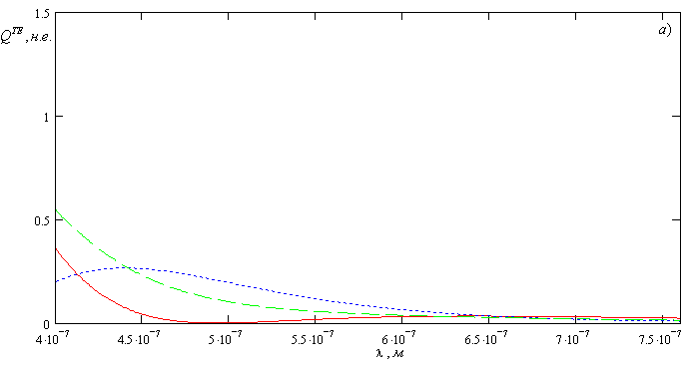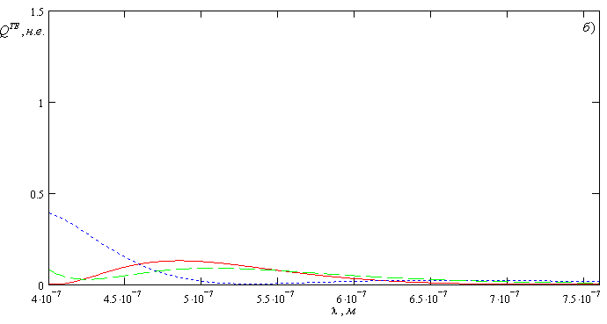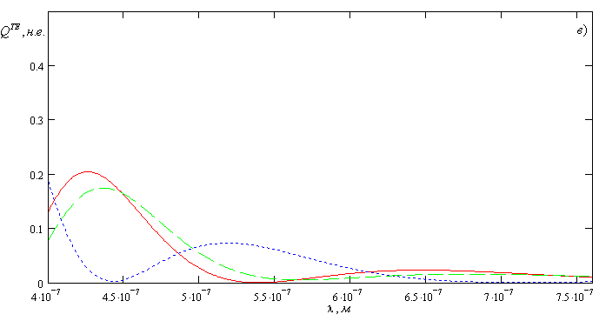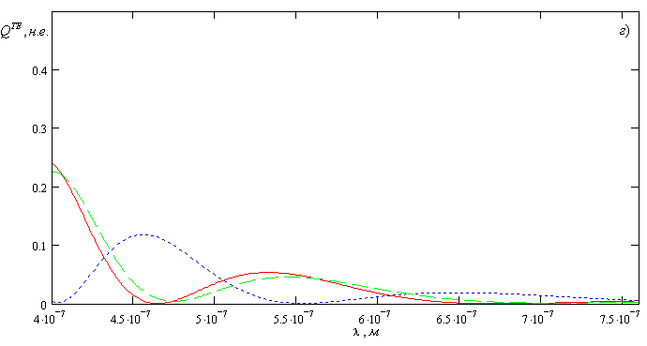

Fig.1 Dependence of quantity distribution of absorbed heat in magnetoactive media $Q^{\text{ТЕ}}(λ)$ on radiation wave length and radial coordinate.
а) $ρ=4⋅{\text{10}}^{−7}м$, b) $ρ=6⋅{\text{10}}^{−7}м$, c) $ρ=8⋅{\text{10}}^{−7}м$, d) $ρ={\text{10}}^{−6}м$.

Further analyze dependence PA signal amplitude in elastic-stressed sample on radiation frequency modulation and geometrical parameters of system “sample-piezodetector”, that is described by equation (12).
It’s seen from graphs, that at optimal choice sample thickness and detector PA signal amplitude can increase several times, that let increase resolution capability of laser PA spectroscopy. Also is necessary to point that on amplitude values of PA resonances influence change of BLB radius and wave length of radiation.
Experimental measurement of resonance signals values taking in consideration expressions (12) let propose means of determination thermophysical, acoustical and dichroic parameters of absorbing elastic-stressed media by method of laser PA spectroscopy.
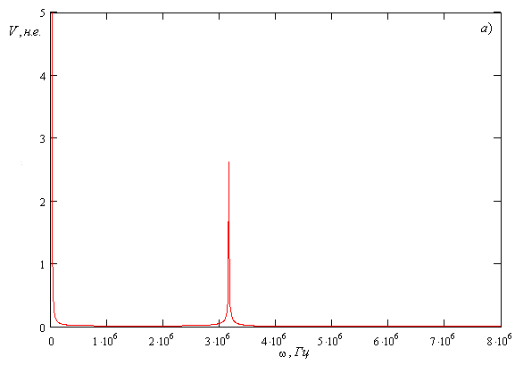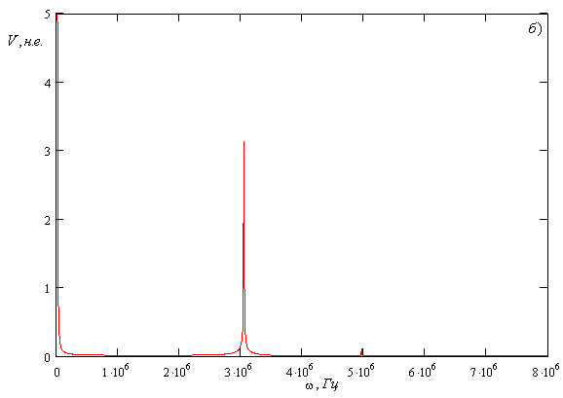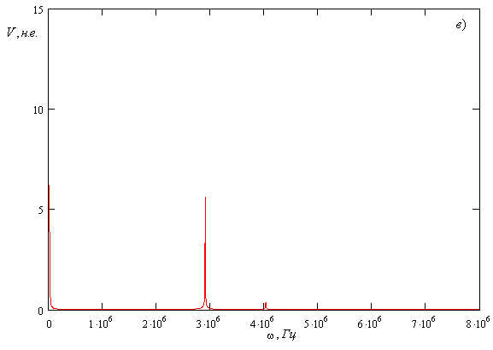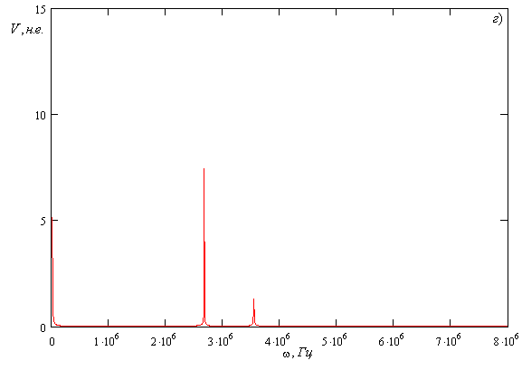
Fig.2 Dependence of PA signal amplitude $V(ω)$ in magnetoactive media on frequency modulation and longitudinal size of sample, $L_{1}=5⋅{\text{10}}^{−4}м$
а) $L=5⋅{\text{10}}^{−3}м$, b) $L=7⋅{\text{10}}^{−3}м$, c) $L=9⋅{\text{10}}^{−3}м$, d) $L=\text{11}⋅{\text{10}}^{−3}м$.
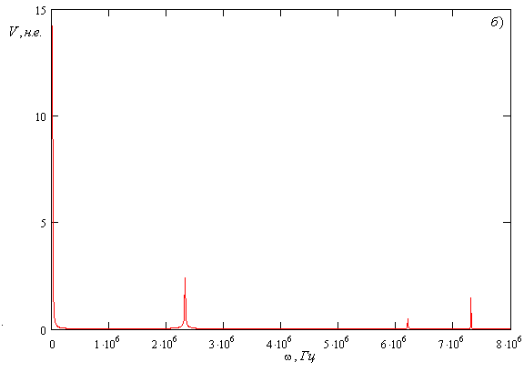Fig.3 Dependence of PA signal amplitude $V(ω)$ in magnetoactive media on frequency modulation and longitudinal size of piezodetector, $L=5⋅{\text{10}}^{−3}м$
а) $L_{1}=5⋅{\text{10}}^{−4}м$, b) $L_{1}=7⋅{\text{10}}^{−4}м$.

Acknowledgements. This work was executed under the partial support of Belarusian Republican Foundation of Fundamental Research F04-316 and State Complex Program of Science Research “PHOTONICS 3.03”.
Abstract. It was fount the expression for amplitude-phase characteristics of photoacoustic signal received from piezotransducer for case free, nonfree and singly nonfree boundaries system sample-piezotransducer. The resonant phenomena were found in a rang of megahertz frequencies of modulation inside on absorbing simple bessel light beams.

References

1. A.Rosencwaig. Photoacousctics and Photoacoustic Spectroscopy. 1980. – 309 p.
2. V.E.Gusev, A.A. Karabutov. Laser Otoacoustics.M.: Science. 1991. – 304 p.
3. G.S.Mityurich, J.Motylewski, J.Ranachowski/ IFTR reports, Polish Academy Science, Warszawa. – № 41. – 1993. – 164 p.
4. Y.V. Gulyaev, A.I. Morozov, V.Y.Raevsky // Acoustic Journal. – V.31. – №4. – 1985. – P. 496 – 473.
5. K. L. Muratikov// Journal Technical Physics. – V. 69. – № 7. – 1999. – P. 59 – 63.
6. A.N. Emelyanovich, G.S. Mityurich, R.M. Burbelo// Photoelectronics. – № 14. – 2005. – P. 8 – 11.
7. Burbelo R.M., Zhabitenko M.K. The mechanism of PA signal formation under pulsed excitation: transiend mode. / Proc. 10th Inter. Conf. on Photoacoustic and Photothermal Phenomena, Roma, 23 – 27 August. – 1998. – P. 353–354.
8. M. Alekseyuk, A.N. Emelyanovich, G.S. Mityurich// Ceramics. – V.61. – 2001. – P. 85 – 91.
9. M. Alekseyuk, A.N. Emelyanovich, G.S. Mityurich// Ceramics. – V.79. – 2003. – P. 30 – 36.
10. J.J. Durnin// JOSA. – 4. – 1987. – P 651
11. D. Mcgloin, V. Graces – Chavez, and K. Dholakia // Opt. Lett. – 28. – 2003. – P. 657.
12. V.N. Belyi, N.S. Kazak, N.A. Hilo // Quantum electronics. – V.30. – №4. – 2002. – P. 753 – 766.
13.. V.I. Fedorov. Theory of gyrotropy. Minsk: Science and Technic. 1976. – 456 p.

¹Belarusian Trade and Economic University, Поступило 11.09.06
246029, Gomel, Belarus
e-mail: george_mityurich@mail.ru

²Gomel State University F.Skorina,
Physical department, 246699, Gomel, Belarus

email: emai-l@mail.ru

³Kiev National University T. Shevchenko,

Physical department, 01033, Kiev 33, Ukraine
email: rmb@univ.kiev.ua

